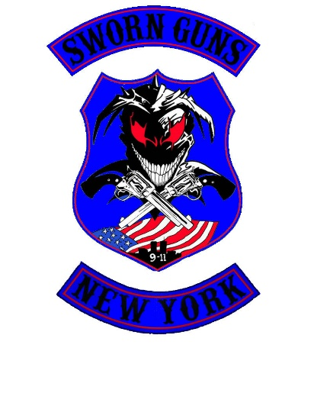**SWORN GUNS MC LTD**  
 501(C) (3) Charity Based Not-For-Profit Organization

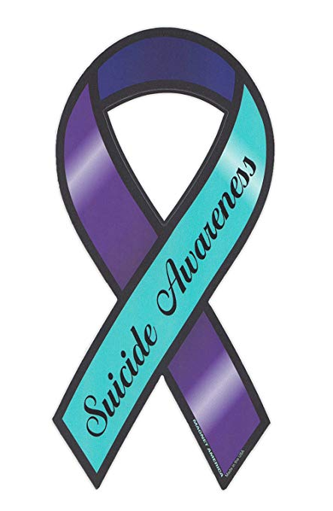

EIN# 83-3317456

PO Box 101, Center Moriches, NY 11934

April, 2025

Dear Friends,

Police related suicide is a condition that grips the men and women of law enforcement and their families all too often. These officers have placed their lives on the line for others, many times the stress of their profession coupled with pressures in their personal lives causes them to reach a point where they feel they can’t go on. Police are accustomed to making split second decisions under stressful circumstances, it is this instinctive ability that facilitates the decision to perceive suicide as an option. A decision that will have the most overwhelming ramifications on everyone they have touched.

With the generous support of “our” riding community and corporate sponsorship, we are hoping to bring awareness to this all-to-prevalent occurrence. All the while, providing much-needed scholarships to the children of our fallen brothers and sisters. We would like to invite you to join us in countering the effects of police suicide by supporting the surviving children of our fallen. This can be accomplished with a simple sponsorship. We have listed the sponsorship packages available, so you may find the one that is right for you, your business or organization! Thank you!

* Diamond Event Sponsors ($1000 minimum) – A large banner bearing your corporate/ organization logo to be displayed at the event- Booth space availability- SGMC “swag” package- Digital advertising and Social Media exposure for your company/ organization - Personalized message of thanks and request to patronize your company/ organization at the event presentation-(2) Rider/ passenger admissions. Corporate sponsors will have their banners featured at all Sworn Guns “Home” events, when applicable.
* Platinum Sponsors ($500) - Your corporate/ organization logo to be printed on the event t-shirt and banner with other sponsors- Booth space availability- SGMC “swag” package- Digital advertising and Social Media exposure for your company/ organization- Rider/ passenger admission
* Gold Sponsors ($300) – Logo appears on a banner with other sponsors-Complimentary event t-shirt and drink koozie- Digital advertising and Social Media exposure for your company/ organization- Rider/ passenger admission
* Silver Sponsors ($225) – (2) Event koozies- Digital advertising and Social Media exposure for your company/ organization- Rider/ passenger admission
* Merchandise – suitable for use as a raffle prizes- Contributor thanked and posted on SGMC website

**As a 501(C) (3) not-for-profit organization, all monetary donations are tax deductible to the fullest extent allowed by law.**

**\*SGMC reserves the right to refuse any sponsor or their affiliated advertising. Receipts available upon request.**